 | MINISTRY OF EDUCATION AND TRAINING

FPT UNIVERSITY
Capstone Project Document
Online Event Management System
Group 17
Group Members | Nguyen Phu Tai Team Leader  Le Hoang Ha Member  Do Tuong Vy Member  Nguyen Duy Thong Member
Supervisor | Nguyen Trong Tai Project Manager
Ext Supervisor | N/A
Capstone Project code | EMS

- Ho Chi Minh City, 08/2013 -

Contents
1. Introduction 3
2. Software Project Management Plan (SPMP) 4
2.1. Problem Definition 4
2.1.1. Name of this Capstone Project 4
2.1.2. Problem Abstract 4
2.1.3. Project Overview 4
2.1.4. Hardware requirements: 4
2.1.5. Software requirements: 4
3. Software Requirements Specifications (SRS) 4
3.1.1. User requirements 4
3.1.2. Event Manager User requirements 4
3.1.3. Admin requirements 4
3.2. System Requirement Specification (Specific Requirements) 5
3.2.1. System Features 5
3.2.2. Software System Attributes 22

Introduction
Today, every company or individual wanted to hold one event must spend effort and time to look to the company organizing the event and wait for the company to determine the time and venue event. Customers are not selected according to individual preferences.

With the advance of digital areas, we give a solution to supports online event planning and event management , namely “EMS - Online Event Management System”.

EMS includes main features such as:
  - Support the website owner to manage the resources (location, …) for planning and organizing events and conferences
  - Support the event manager users to request for organizing event, planning and execution of the events (or conferences)
  - Support the audience users to book the events (or conferences)

EMS will bring users a better experience by saving time, efforts and offering more options to choose when organizing an event.

Software Project Management Plan (SPMP)

Problem Definition

Name of this Capstone Project
The official name of this project is “Online Event Management System”. The project code is “EMS”.

Problem Abstract

Project Overview

Hardware requirements:
- Personal computers for developing with the minimum configuration: CPU Core 2 Duo 2.0GHz, 2GB of RAM, 120GB of hard disk or above, and the internet.

Software requirements:

Software Requirements Specifications (SRS)

User requirements
- Register and sign in
- Booking the event

Event Manager User requirements
- Request for Organizing Event
- Planning and Execution of the events

Admin requirements
- Manage Resource
- Manage User
- Manage Fee
- Search
- Statistic
- Manage requesting and booking
- Manage event planning and organizing

System Requirement Specification (Specific Requirements)
System Requirement Specification will provide an overview of all features. Each feature is a group of similar use cases. System will provide these features to satisfy user requirements.
Users who can interact directly with the system can be divided into 3 kinds of actors as follows:
No. | Actor | Description
1 | User | Guest who had registered an account
2 | Event Manager User | User who provide wedding service for website
3 | Admin | User who has the right of administration

System Features
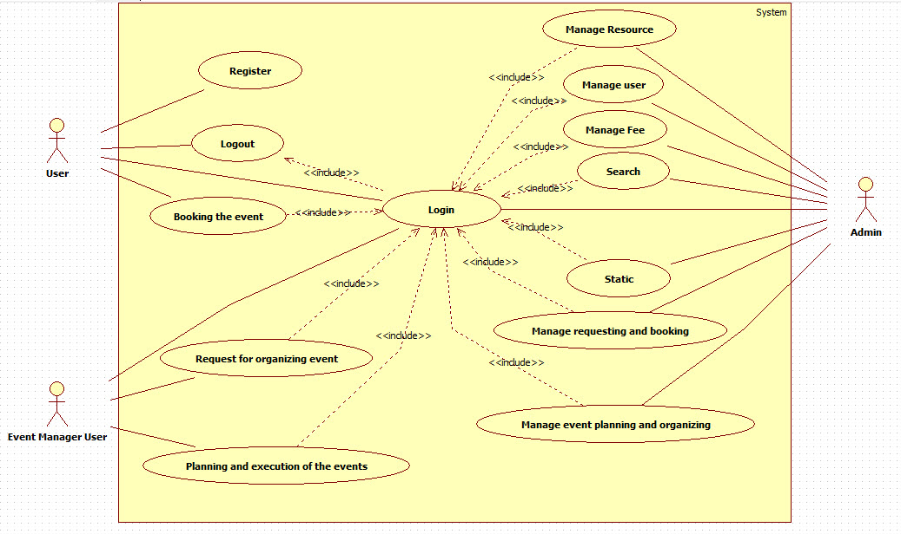
All System Use case

User Features
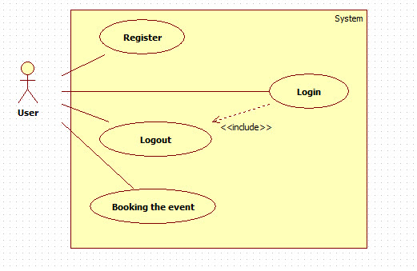
User Feature use case

<User> Register

Use Case Diagram
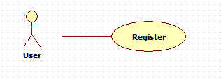

Use Case Specification
USE CASE REGISTER SPECIFICATION
Use-case No. | UC-U001 | Use-case Version |  | 0.1
Use-case Name | User Register
Author | Do Tuong Vy
Date | 20/8/2013 | Priority | Low
Actor | User
Summary | This use case is about Register function
Goal | User can register to be a User of the system
Triggers | N/A
Preconditions | User accessed homepage
Post Conditions | Forward to Welcome Page
Main Success Scenario
- Customer clicks “Sign-up” (Đăng ký) button.
- System forwards to “Register” page.
- User inputs email and password.
- User inputs account information (optional).
- User clicks “Sign up” (Đăng ký) button.
- System forwards to Successful Sign-up modal, then redirect to Welcome Page.
Alternative Scenario
- User clicks “Home” (Trang chủ) button.
- System forwards to “Home” (Trang chủ) page. No information is recorded.
Exceptions
- If inputted user name is not available (another user already registered it), system will show notification and request guest to enter a new one (back to step 4).
- If inputted information is not valid, system will show an error message and request guest to input valid information (back to step 5).
Relationships | N/A
Business Rules | N/A

< User> Login

Use Case Diagram
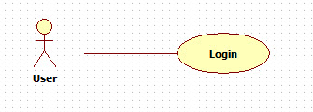

Use case Specification
USE CASE LOGIN SPECIFICATION
Use-case No. | UC-U002 | Use-case Version |  | 0.1
Use-case Name | User Login
Author | Do Tuong Vy
Date | 20/8/2013 | Priority | Low
Actor | User
Summary | This use case is about user function
Goal | The user login successfully out of the system
Triggers | Actor behavior
Preconditions | N/A
Post Conditions | User login successfully
Main Success Scenario
- User input email and password
- User clicks “Login” (Đăng nhập) button
- System is forward to “Home” page
Alternative Scenario N/A
Exceptions | N/A
Relationships | N/A
Business Rules | N/A

<User> Logout

Use Case Diagram
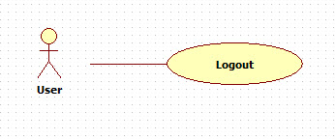

Use Case Specification
USE CASE LOGOUT SPECIFICATION
Use-case No. | UC-U003 | Use-case Version |  | 0.1
Use-case Name | User Logout
Author | Do Tuong Vy
Date | 20/8/2013 | Priority | Low
Actor | User
Summary | This use case is about user function
Goal | The user logout successfully out of the system
Triggers | Actor behavior
Preconditions | The user login into the system
Post Conditions | N/A
Main Success Scenario
- User clicks “Log out” (Thoát) button
- System is forward to “Home” page
Alternative Scenario N/A
Exceptions | N/A
Relationships | N/A
Business Rules | N/A

<User> Booking the event

Use Case Diagram
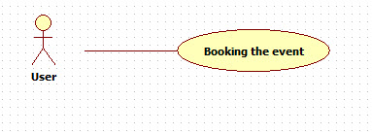

Use Case Specification
USE CASE BOOKING THE EVENT SPECIFICATION
Use-case No. | UC-U004 | Use-case Version |  | 0.1
Use-case Name | User Booking The Event
Author | Do Tuong Vy
Date | 20/8/2013 | Priority | Low
Actor | User
Summary | This use case is about user function
Goal | The user booking successfully the event
Triggers | Actor behavior
Preconditions | The user login into the system
Post Conditions | N/A
Main Success Scenario
Alternative Scenario N/A
Exceptions | N/A
Relationships | N/A
Business Rules | N/A

Event Manager User Features
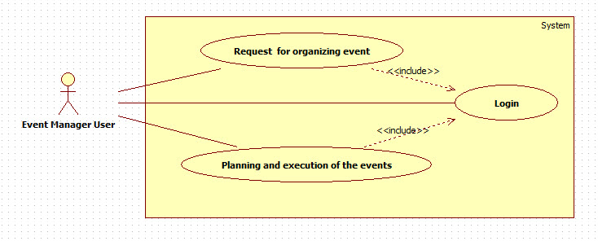
Event Manager User Feature use case

< Event Manager User> Login

Use Case Diagram
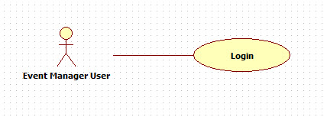

Use Case Specification
USE CASE LOGIN SPECIFICATION
Use-case No. | UC-E001 | Use-case Version |  | 0.1
Use-case Name | Event Manager User Login
Author | Do Tuong Vy
Date | 20/8/2013 | Priority | Low
Actor | Event Manager User
Summary | This use case is about Event Manager User function
Goal | The event Manager User login successfully out of the system
Triggers | Actor behavior
Preconditions | N/A
Post Conditions | Event Manager User login successfully
Main Success Scenario
- Event Manager User input email and password
- Event Manager User clicks “Login” (Đăng nhập) button
- System is forward to “Home” page
Alternative Scenario N/A
Exceptions | N/A
Relationships | N/A
Business Rules | N/A

<Event Manager User> Request for organizing event

Use Case Diagram
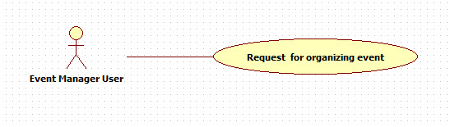

Use Case Specification
USE CASE REQUEST FOR ORGANIZING EVENT SPECIFICATION
Use-case No. | UC-E002 | Use-case Version |  | 0.1
Use-case Name | Event Manager request for organizing event
Author | Do Tuong Vy
Date | 20/8/2013 | Priority | Low
Actor | Event Manager User
Summary | This use case is about Event Manager User function
Goal | The Event Manager User can send request for organizing event
Triggers | Actor behavior
Preconditions | N/A
Post Conditions | Event Manager User must be log in
Main Success Scenario
Alternative Scenario N/A
Exceptions | N/A
Relationships | N/A
Business Rules | N/A

<Event Manager User> Planning and execution of the events

Use Case Diagram
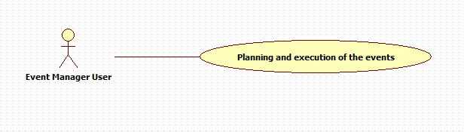

Use Case Specification
USE CASE PLANNING AND EXECUTION OF THE EVENTS SPECIFICATION
Use-case No. | UC-E003 | Use-case Version |  | 0.1
Use-case Name | Event Manager planning and execution of the events
Author | Do Tuong Vy
Date | 20/8/2013 | Priority | Low
Actor | Event Manager User
Summary | This use case is about Event Manager User function
Goal | The Event Manager User plans and executes successfully the events
Triggers | Actor behavior
Preconditions | N/A
Post Conditions | Event Manager User must be log in
Main Success Scenario
Alternative Scenario N/A
Exceptions | N/A
Relationships | N/A
Business Rules | N/A

Admin Features
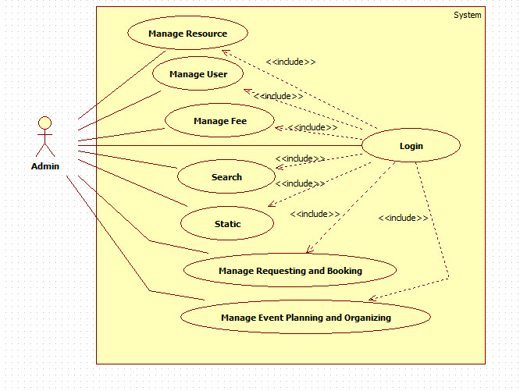

<Admin> Login

Use Case Diagram
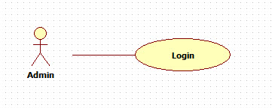

Use Case Specification
USE CASE LOGIN SPECIFICATION
Use-case No. | UC-A001 | Use-case Version |  | 0.1
Use-case Name | Admin Login
Author | Do Tuong Vy
Date | 20/8/2013 | Priority | Low
Actor | User
Summary | This use case is about admin function
Goal | The admin login successfully out of the system
Triggers | Actor behavior
Preconditions | N/A
Post Conditions | Admin login successfully
Main Success Scenario
- Admin input email and password
- Admin clicks “Login” (Đăng nhập) button
- System is forward to “Admin” page
Alternative Scenario N/A
Exceptions | N/A
Relationships | N/A
Business Rules | N/A

<Admin> Manager User

Use Case Diagram
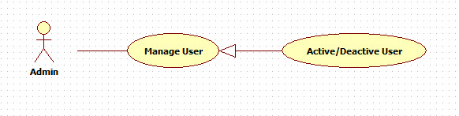

Use Case Specification
USE CASE ACTIVATE/DEACTIVATE SPECIFICATION
Use-case No. | UC-A002 | Use-case Version |  | 0.1
Use-case Name | Admin Activate/Deactivate User
Author | Do Tuong Vy
Date | 20/08/2013 | Priority | Normal
Actor | Admin
Summary | This use case is about Activate/Deactivate user function
Goal | Admin can activate/deactivate user.
Triggers | Start when the admin clicks “Kích hoạt”/”Vô hiệu hóa” button
Preconditions | Admin logged in system with Admin role.  Admin accessed Admin Management Page
Post Conditions | Admin activate/deactivate user successfully.  User is activated/deactivated
Main Success Scenario
- In a list of user, Admin clicks on “Kích hoạt”/”Vô hiệu hóa” button next to the user Admin want to activate/deactivate.
- System changes state of selected user. Data will be saved in database.
- Button change.
Alternative Scenario N/A
Exceptions N/A
Relationships | N/A
Business Rules | N/A

<Admin> Manage Resource

Use Case Diagram
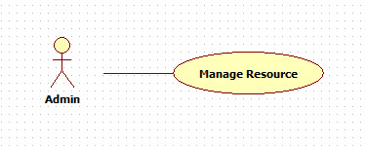

Use Case Specification
USE CASE MANAGE RESOURCE SPECIFICATION
Use-case No. | UC-A003 | Use-case Version |  | 0.1
Use-case Name | Admin Manage Resource Of Event
Author | Do Tuong Vy
Date | 20/08/2013 | Priority | Normal
Actor | Admin
Summary | This use case is about Manage function
Goal | Admin can add/edit/delete the time, the location, the fee of event in the resource list.
Triggers | Start when the admin clicks “Resource” button
Preconditions | Admin logged in system with Admin role.  Admin accessed Admin Management Page
Post Conditions | Admin add/edit/delete the time, the location, the fee of event in the resource list successfully.
Main Success Scenario
- In a Admin Management Page, Admin clicks on “Resource” button.
- Admin click on “Add”/”Edit”/”Delete” button to manage resource.
Alternative Scenario N/A
Exceptions N/A
Relationships | N/A
Business Rules | N/A

<Admin> Search

Use Case Diagram
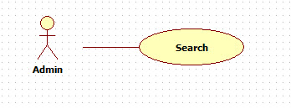

Use Case Specification
USE CASE SEARCH SPECIFICATION
Use-case No. | UC-A004 | Use-case Version |  | 0.1
Use-case Name | Admin Search
Author | Do Tuong Vy
Date | 20/08/2013 | Priority | Normal
Actor | Admin
Summary | This use case is about Search function
Goal | Admin can search user/provider.
Triggers | Start when the admin enter search box and clicks search button/press enter
Preconditions | Admin logged in system with Admin role.  Admin accessed Admin Management Page
Post Conditions | Search result is displayed
Main Success Scenario
1. In search box, Admin enter keyword and clicks search button next to search box.
2. Users/Providers have email contain keyword will be listed
Alternative Scenario N/A
Exceptions N/A
Relationships | N/A
Business Rules | N/A

<Admin> Manage Fee

Use Case Diagram
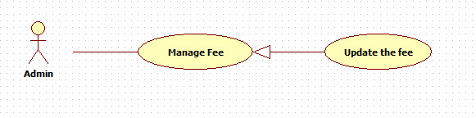

Use Case Specification
USE CASE MANAGE FEE SPECIFICATION
Use-case No. | UC-A005 | Use-case Version |  | 0.1
Use-case Name | Admin manage the fee of event
Author | Do Tuong Vy
Date | 20/08/2013 | Priority | Normal
Actor | Admin
Summary | This use case is about Manager function
Goal | Admin can update the fee of the event when it changed.
Triggers | Start when the admin clicks “Manage Fee” button
Preconditions | Admin logged in system with Admin role.  Admin accessed Admin Management Page
Post Conditions
Main Success Scenario
1. In Admin Management Page, Admin clicks on “Manage Fee” button.
2. Select the resource which chagned the fee and click on “Update fee”.
3. Enter the new fee.
Alternative Scenario N/A
Exceptions N/A
Relationships | N/A
Business Rules | N/A

<Admin> Statistic

Use Case Diagram
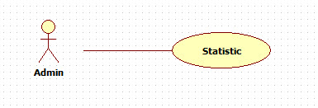

Use Case Specification
USE CASE STATISTIC SPECIFICATION
Use-case No. | UC-A006 | Use-case Version |  | 0.1
Use-case Name | Admin Search
Author | Do Tuong Vy
Date | 20/08/2013 | Priority | Normal
Actor | Admin
Summary | This use case is about Statistic function
Goal | Admin can statistic the event by day/month/year.
Triggers | Start when the admin click the “Statistic” button
Preconditions | Admin logged in system with Admin role.  Admin accessed Admin Management Page
Post Conditions | Result is displayed
Main Success Scenario
1. In Admin Management Page, Admin clicks on “Statistic” button.
2. Click “Day”/”Month”/”Year” button to statistic.
Alternative Scenario N/A
Exceptions N/A
Relationships | N/A
Business Rules | N/A

<Admin> Manage Requesting and Booking

Use Case Diagram
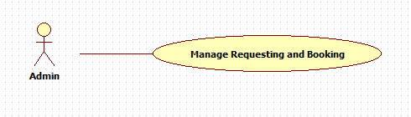

Use Case Specification
USE CASE MANAGE REQUESTING AND BOOKING SPECIFICATION
Use-case No. | UC-A007 | Use-case Version |  | 0.1
Use-case Name | Admin manage requesting and booking of event
Author | Do Tuong Vy
Date | 20/08/2013 | Priority | Normal
Actor | Admin
Summary | This use case is about Manager function
Goal | Admin can accept/decline the event manager user’s request, and accept/decline the user’s booking
Triggers | Start when the admin clicks “Manage requesting and booking” button
Preconditions | Admin logged in system with Admin role.  Admin accessed Admin Management Page
Post Conditions
Main Success Scenario
1. In Admin Management Page, Admin clicks on “Manage requesting and booking” button.
2. Select tab “Requesting”/”Booking” to display the list of requesting/booking.
3. Click on “Accept”/”Decline” next to each requesting/booking.
Alternative Scenario N/A
Exceptions N/A
Relationships | N/A
Business Rules | N/A

<Admin> Manage Event Planning and Organizing

Use Case Diagram
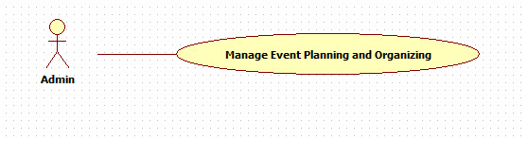

Use Case Specification
USE CASE MANAGE EVENT PLANNING AND ORGANIZING SPECIFICATION
Use-case No. | UC-A008 | Use-case Version |  | 0.1
Use-case Name | Admin manage event planning and organizing
Author | Do Tuong Vy
Date | 20/08/2013 | Priority | Normal
Actor | Admin
Summary | This use case is about Manager function
Goal
Triggers | Start when the admin clicks “Manage event planning and organizing” button
Preconditions | Admin logged in system with Admin role.  Admin accessed Admin Management Page
Post Conditions
Main Success Scenario
1.

Alternative Scenario N/A
Exceptions N/A
Relationships | N/A
Business Rules | N/A

Software System Attributes

Reliability
System should deliver services as user’s expectation. The system must be prevented from producing unexpected errors or incorrect output. In general, system must ensure the followings:
- Specific system’s functions are visible for only authorized user. For example, only administrator can manage categories
- Give correct response to user operation. For example, moving from screen to screen.
- Give accurate result to user operation. For example, searching or report generating.
- In case of failure, system should show appropriate message and keep records to make sure user operation can be recovered with minimum loss of user input.

Availability
N/A

Security
- Only user with valid account and authorized role can access certain system functions.
- Prevent everyone, including system administrator, from knowing users’ passwords. When forgetting password, user can request system admin to reset their password and receive a new one.
- Keep log and history data
- Check data integrity and validate input before execute recording into database system

Maintainability
New requirement can be demanded when system is deployed. So the system should be able to change. Development process must provide the way to modify and extend.
- Delivery product must have the software application packaged with all documented software requirements, software design, testing report and other material if any (so you can transfer for new team in the future)
- For source code, all files and modules should have java doc and/or comment with short description and records of modification.
- In case of maintenance, a maintaining message should be shown to users when they enter to the website.

Portability
User with personal computer, which has an internet browser, should be able to use this system. Therefore, the website should be developed and tested on popular web browsers, such as Internet Explorer, Mozilla Firefox and Google Chrome.

Performance
N/A

